Apache Kafka Installation

Visit below official kafka website

Download 2.12 and unarchive kafka using win rar

Rename folder to kafka and put it directly under c drive

Download java from [Java Archive Downloads - Java SE 11 | Oracle India](https://www.oracle.com/in/java/technologies/javase/jdk11-archive-downloads.html)

and install java

Add java to your path

Open Power shell in windows and validate installation

1. Java -version
2. Change folder to kafka cd c:\Kafka

Install V S Code and then open kafka folder in V S Code

Inside kafka folder create two folder:- 1. Kafka-logs 2. Zookeeper

Then go to config folder and inside that open server.properties file

Go to line 62 and change logs.dir value to log.dirs=C:/kafka/kafka-logs

Then again in the config open zookeeper.properties file

In line 16 change dataDir value to dataDir=C:/kafka/zookeeper

Then in power shell go to kafka directory and enter below command to start zookeeper server:-

.\bin\windows\zookeeper-server-start.bat .\config\zookeeper.properties

Then Open another power shell go to kafka directory and enter below command to start kafka server:-

.\bin\windows\kafka-server-start.bat .\config\server.properties

Ports:- zookeeper localhost:2181 broker(server) localhost:9092

Then Open another power shell go to kafka directory and enter below command to create a new topic:-

.\bin\windows\kafka-topics.bat --create --bootstrap-server localhost:9092 --topic test

Let’s send and consume some messages:-

Let’s open a power shell and go to kafka directory and enter below command to start a producer:-

.\bin\windows\kafka-console-producer.bat --broker-list localhost:9092 --topic test

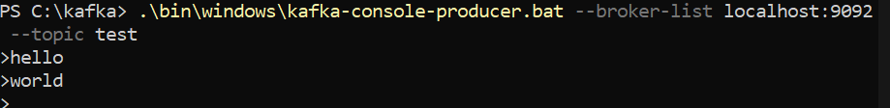

This will start a producer server on the same power shell window. Here whatever you will be typing will be broadcasted to producer server window.

To consume these messages let’s open a power shell and go to kafka directory and enter below command to start a consumer:-

.\bin\windows\kafka-console-consumer.bat --bootstrap-server localhost:9092 --topic test

